MASTER CONTROL OPERATIONS @ Compusat PC

RE: Compusat

COMPUSAT MAIN SCREEN

Satellite Receiver Display EASI Antenna Display
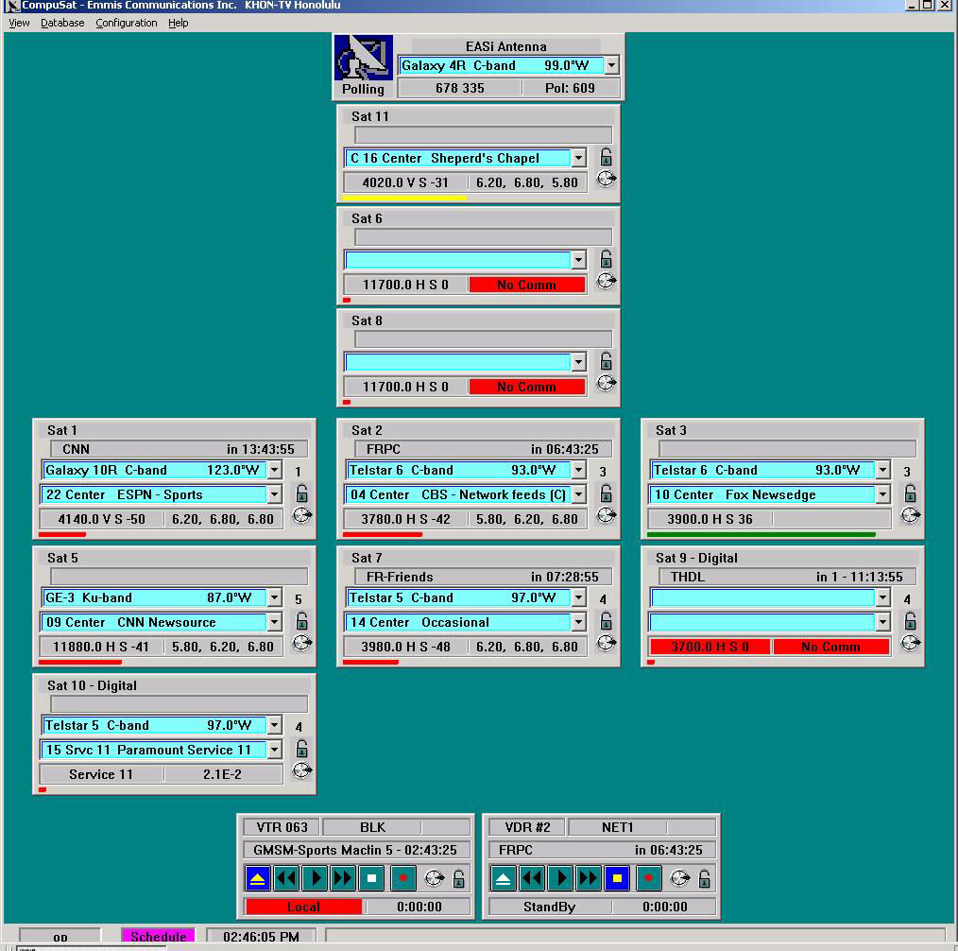

Log on as “OP” Click on SCHEDULE VTR Video
No password to view Event Schedule Display Disk Display
MASTER CONTROL OPERATIONS @ Compusat PC

Compusat

SELECTING A NEW SATELLITE (EASI Antenna)
- Click the Dropdown list on the EASI Antenna Controller
- Scroll to the Satellite required
- Click on the Satellite
- Box reads “Is it OK to move the antenna?”
- Answer YES if antenna is not in use and you want to tune it
- Answer NO if you do not want the antenna to move
Click here for list
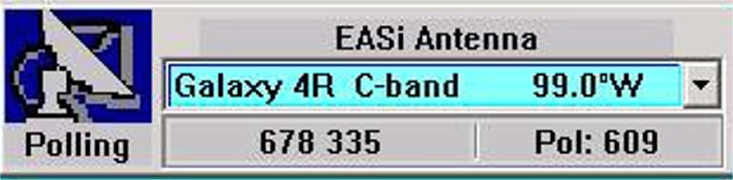

Satellite Selection Azimuth-Elevation Polarization

SELECTING A NEW SATELLITE (Harris Steerable Antenna)
- Manually move the antenna to the required satellite
- @SAT1 Receiver, scroll to the required satellite
- Click on the required satellite

Transponder Event Bar Satellite Scroll to Satellite

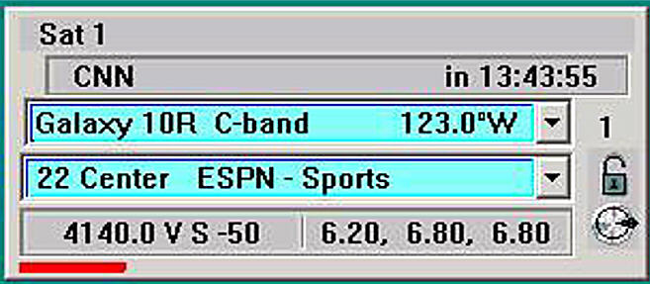

Transponder Audio Tuning Lock

Frequency Box Subcarrier Box Knob

MASTER CONTROL OPERATIONS @ Compusat PC

SELECTING A NEW TRANSPONDER
- Click the Dropdown list on the receiver
- The list displays all transponders available for the currently selected satellite
- Scroll to the required transponder
- Click on the transponder

CHANGING THE AUDIO SUBCARRIER
- Press the Subcarrier info box on the receiver
- The list displays subcarrier combinations for the current transponder
- Scroll to the subcarrier combination desired
- Click on the subcarrier combination

Audio Subcarrier Choices Level Adjustments

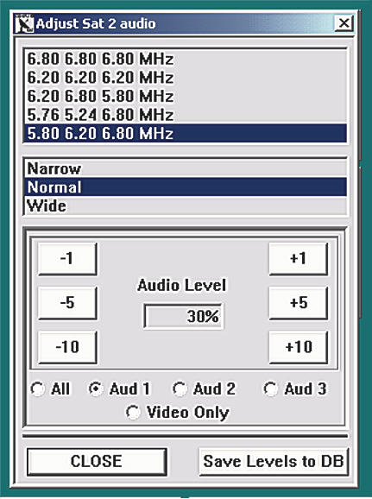

Audio Selections Video Selection Save to Database

MASTER CONTROL OPERATIONS @ Compusat PC

AUDIO and VIDEO LEVEL ADJUSTMENTS
- Click on the Aud 1
- Click on box a box to raise or lower the Audio Level
- Repeat Steps 1 and 2 for Aud 2
- Click Video Only
- Click on box a box to raise or lower the Video Level
- Once proper levels are set, Click Save Levels to DB
- When done, Click on CLOSE

TYPES of EVENTS
- SATELLITE EVENT – Controls Satellite Dish (Antenna) and Satellite Receiver
- VTR EVENT – Controls VTR or Video Disk, routes signal to the Record Device
- ROUTER EVENT – Controls Router Source and Destination Crosspoints

All of the above events will control the specified devices at the required times.

MASTER CONTROL OPERATIONS @ Compusat PC

Name of Event Type of Event Satellite Channel Audio Sub

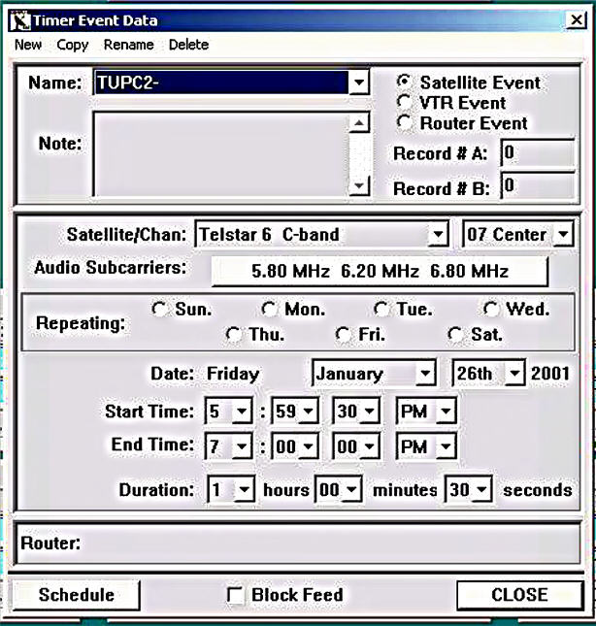

Repeating Day Duration End Time Start Time OTO Date

CREATING A NEW SATELLITE EVENT
- Scroll to the desired Transponder
- Click on the day if the event Repeats
- Enter the date for the event if it is a One Time Only event
- Click on the Event bar @ Main menu
- Click on EDIT EVENTS
- Display should be the TIMER EVENT DATA screen
- Click on NEW
- Click on SATELLITE EVENT
- Type the name of the event (Compusat will use the 1st 4 characters for the event ID)
MASTER CONTROL OPERATIONS @ Compusat PC

10)Click on OK
11)Click on the Down Arrow (Satellite/Channel)
12)Scroll to the desired Satellite
13)Click on the Down Arrow
14)Enter the Start Time of the Event, Compusat will start the recording
:30 sec prior to the entered Start Time
15)Enter the Duration
16)Click on the Audio Subcarrier info box
17)Click on the required Audio Subcarrier set
18)Click on OK

CREATING A NEW VIDEO DISK (or VTR EVENT)
- Click on NEW
- Enter the NAME
- Click on OK
- Click VTR EVENT
- @ Router Source, scroll to and highlight the desired source
- Click on Day of the Week if the Event repeats
- Enter DATE info if a OTO event (one time only)
- Enter START TIME and DURATION
- Click on OK

CREATING A NEW ROUTER EVENT
- Click on NEW
- Enter NAME
- Click on OK
- Click on ROUTER EVENT
- @ Router Source, scroll to and highlight the desired source
- @ Router Destination, scroll to and highlight the desired destination
- Click on the Day if the Event repeats
- Enter DATE info if a OTO event (one time only)
- Enter START TIME and DURATION
10)Click on OK

SCHEDULING A SATELLITE EVENT
- Click on the Receiver name
- The list displays the events for the receiver
- Click the Schedule button
- The Display shows a list with two panes
- The Right pane shows Events that are available
- The Left pane shows Events already scheduled
- Double click the desired event in the Right pane
- The Event is now Scheduled and shows up in the Left pane
- The Current (In progress) event or the next scheduled event is shown on the receivers front panel display
- The Front panel also displays the Time Remaining of the In progress event, or the time until the next event commences

UNSCHEDULING A SATELLITE EVENT
- Click on the Receiver name
- The list displays the events for the receiver
- Click the Schedule button
- The Display shows a list with two panes
- The Right pane shows Events that are available
- The Left pane shows Events already scheduled
- Double click on the Event in the Left pane
- The Event is no longer Scheduled, the Event now appears in the Right pane

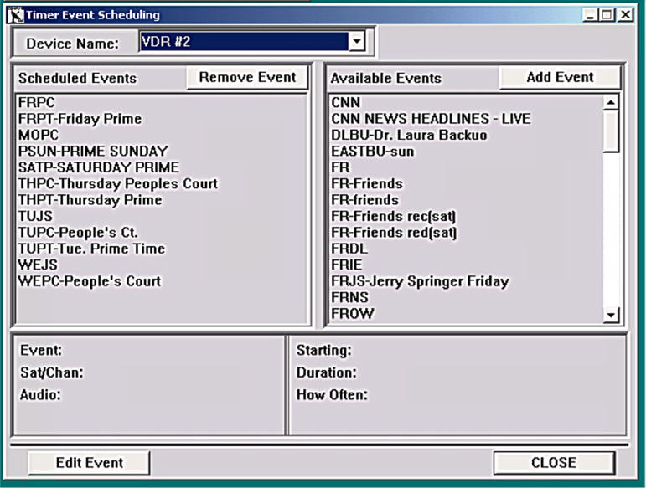

SCHEDULING A VTR or DISK EVENT
- Click on the VTR or Video Disk next event display
- The list displays the events for the Record device
- Click the Schedule button
- The Display shows a list with two panes
- The Right pane shows Events that are available
- The Left pane shows Events already scheduled
- Double click the desired event in the Right pane (Use the previously created Satellite event to Schedule the VTR or Video Disk. You create the Satellite Event and use it to schedule both the Satellite Receiver and the Video Disk or VTR)
- The Event is now Scheduled and shows up in the Left pane
- The Current (In progress) event or the next scheduled event is shown on the VTR or Disk front panel display
- The Front panel also displays the Time Remaining of the In progress event, or the time until the next event commences

MASTER CONTROL OPERATIONS @ Compusat PC

VTR Name Router Source Video Disk Name Router Source

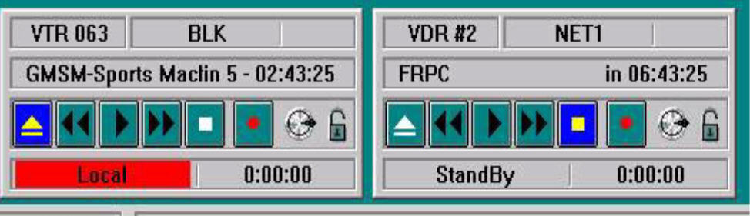

Current or Next Event

Time of Current or Time until Next Event

TIMER EVENT for RECORDINGS
TIMER EVENTS for Satellite Recordings require both the Satellite Receiver and the Disk Recorder (or VTR) to be scheduled for the same Event, they should both appear on the SCHEDULED TIMER EVENTS list.

TIMER EVENTS FOR Recordings that only involve switching the Router (do not involve tuning a Satellite Receiver) need to be Scheduled only on the Video Disk or VTR. It will appear on the SCHEDULED TIMER EVENT LIST with only the Video Disk (or VTR) scheduled.

MASTER CONTROL OPERATIONS @ Compusat PC

SCHEDULED EVENTS LIST
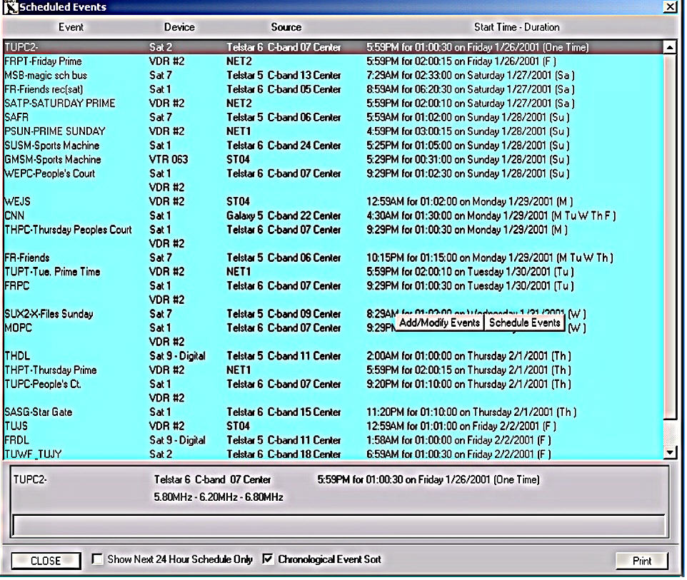

AUTOMATIC ROUTING
If you schedule the same event on both the Satellite Receiver and the VTR or Video Disk, then Compusat automatically routes the Satellite signal to the VTR or Video Disk.

CHECKING THE LIST OF SCHEDULED TIMER EVENTS
- Click on the SCHEDULE button at the bottom of the screen
- The display shows all SCHEDULED EVENTS in chronological order. Verify this list against the Record list provided by the Programming Dept.
- Satellite RECORD EVENTS should show a Satellite Receiver and a VTR or Video Disk scheduled for that event.

